Edser Orthotic Labs has developed the first complete orthotic diagnostic center. The integrated system is built around true 3D scanning to create a digital cast for custom orthotic fabrication. Edser now offers a pressure platform for gait analysis and video camera capture, all incorporated in one easy-to-use software.
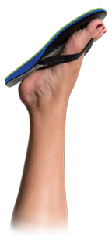
Custom Made Flopthotics
After a day at the beach or a weekend relaxing in flip flops, the comfort of wiggling toes often turns to sore and aching feet. Although everyone loves flip flops, we can agree the lack of support is unhealthy for your feet, knees, hips and back. Edser Orthotic Labs found the solution to keep you and your patients happy with the first true CUSTOM MADE FLIP FLOP to provide feet the support and correction they need.
Our Custom Made FlopThotics are recommended in combination with use of Custom Made Orthotics in everyday and exercise shoes. Although closed toed shoes provide the best support for the foot and ankle, the Edser Flopthotic provides a logical alternative. Best of all, now patients never have to go without custom made orthotic support!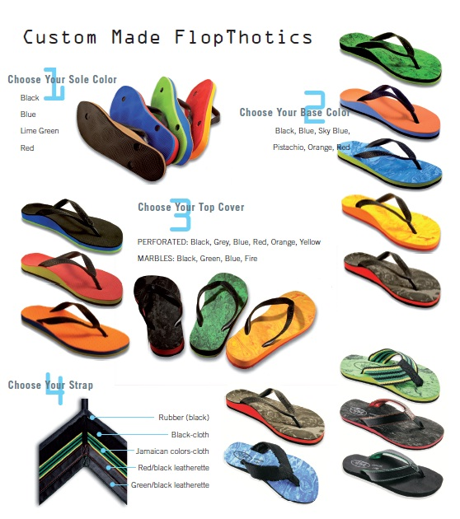
Woman’s Sandals
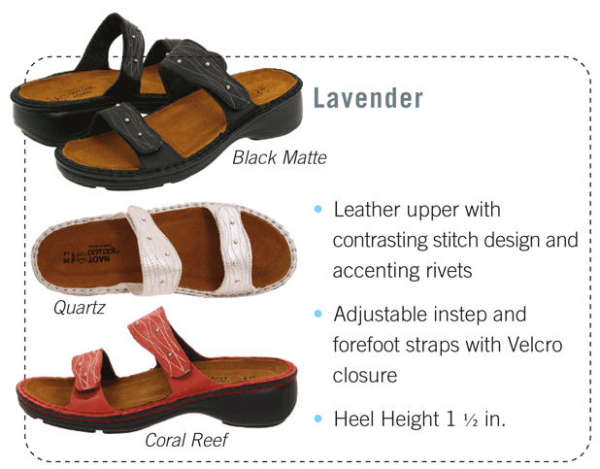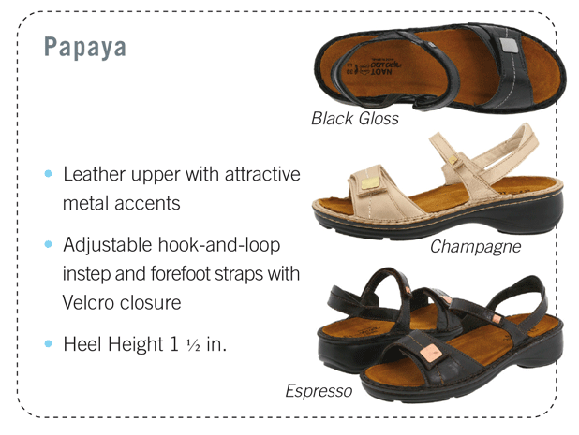
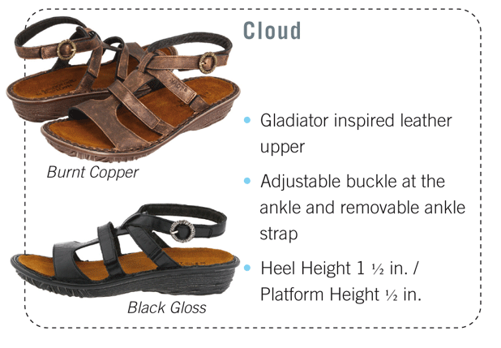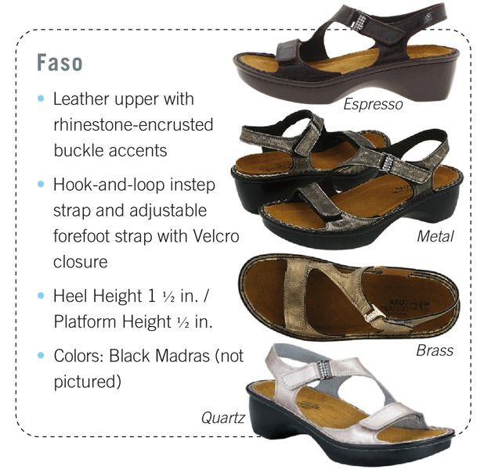
Men’s Sandals
